SUPPLY CHAIN ANALYSIS
Analytical report based on the supplied Supply Chain Analysis notebook and its reported outputs.

1. Executive Summary
The dataset contains 180,519 order records. The reported late-delivery rate is 54.70%, compared with 45.30% on-time delivery. Reported total order profit is $7.85M. The notebook also reports $2.15M as profit associated with delayed orders; this should be interpreted as profit on delayed orders, not confirmed profit lost because of delays, unless a counterfactual loss calculation is performed.
Key finding | Reported metric
Overall late-delivery rate | 54.70%
On-time delivery rate | 45.30%
Orders analyzed | 180,519
Total order profit | $7.85M
Profit on delayed orders (as reported) | $2.15M
Random Forest accuracy (reported) | 73%
Management takeaway: late delivery is widespread rather than isolated to one month or weekday. Prioritize shipping-mode and payment/status bottleneck checks, and validate the definition of delay-related loss before using it as a financial-loss KPI.

2. Profitability Analysis

2.1 Order-level profitability distribution
The notebook labels 145,558 orders as profitable and 34,961 as loss/non-positive-profit. That is approximately 80.6% versus 19.4%. Because the second group may include orders with exactly zero profit, it is safer to call it “non-positive profit” unless the source logic confirms every order has negative profit.
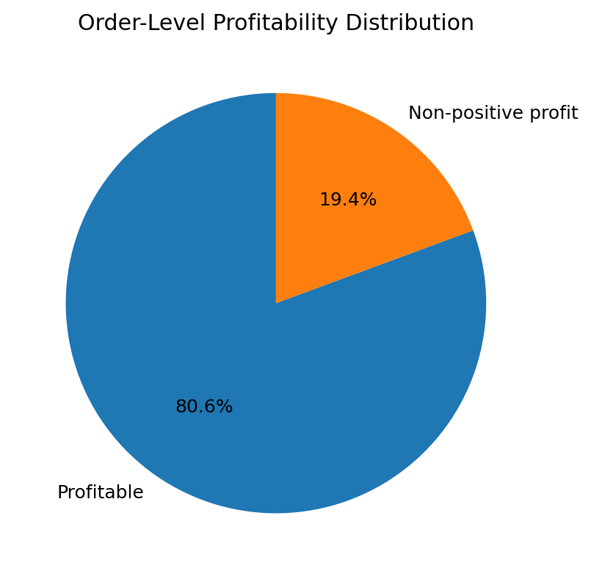

2.2 Profit by delivery delay
The highest total profit appears in the +1 day delay group, largely reflecting order volume in that group. Total profit is not the same as profit per order, so both measures should be reviewed together.
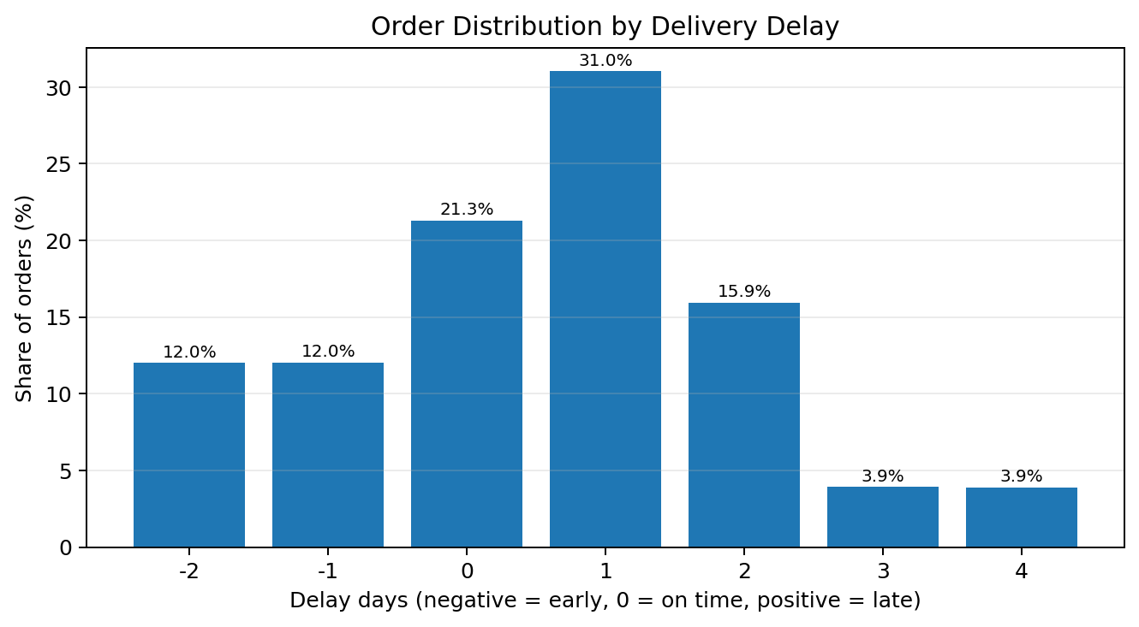
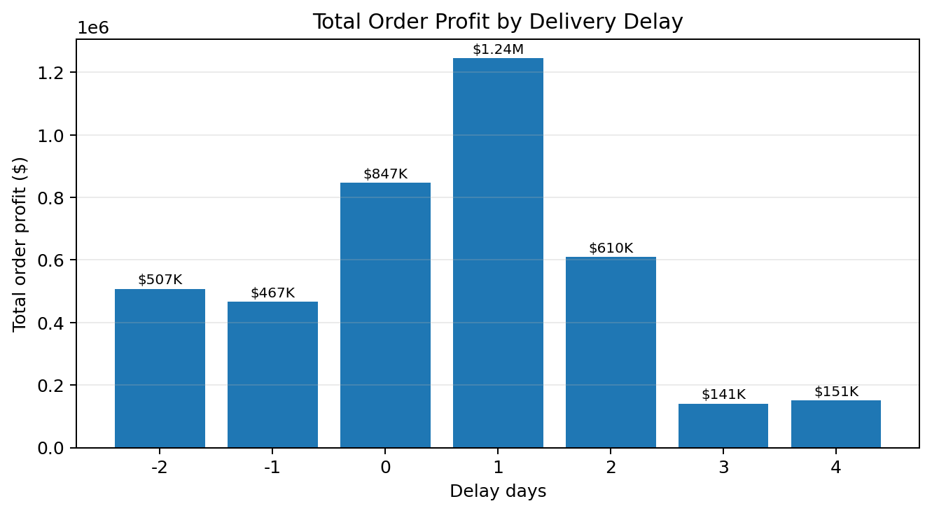
Average profit per order by delay day: -2 day(s): $23.42; -1 day(s): $21.52; on time: $22.04; +1 day(s): $22.23; +2 day(s): $21.25; +3 day(s): $19.94; +4 day(s): $21.56.
Interpretation: average profit differs only modestly across delay groups in these outputs. This alone does not prove delays cause lower profit; order mix, product mix, shipping fees, and customer/order characteristics may also affect profit.

3. Delivery Performance and Trends

3.1 Late delivery by month
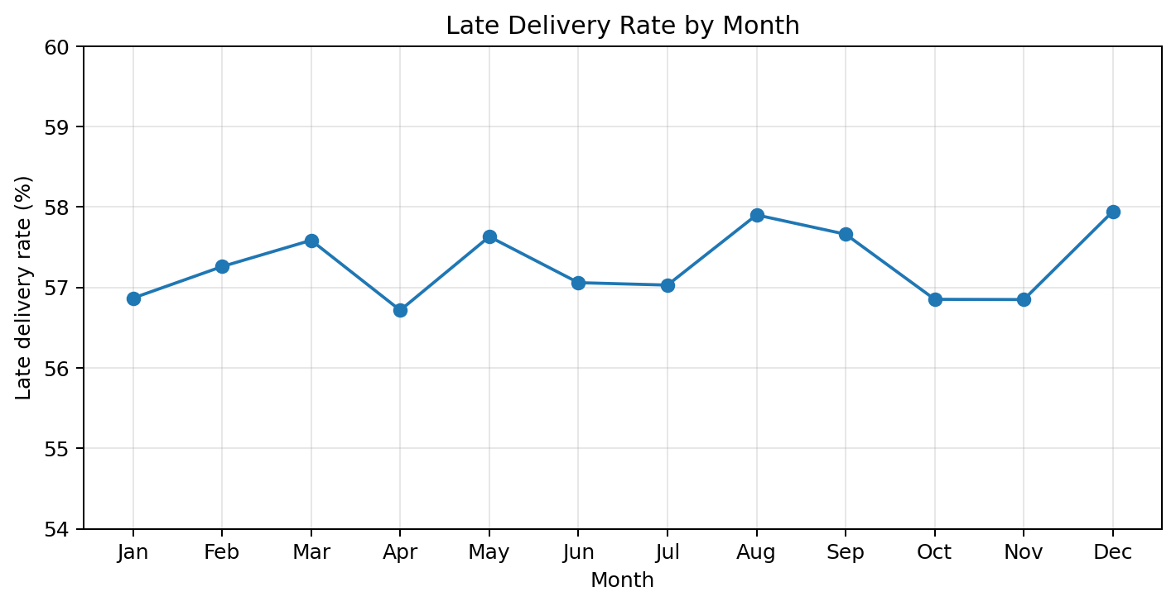
Monthly late-delivery rates range from 56.72% (Apr) to 57.94% (Dec). The narrow range suggests the issue persists throughout the year rather than being confined to a single month.

3.2 Late delivery by weekday
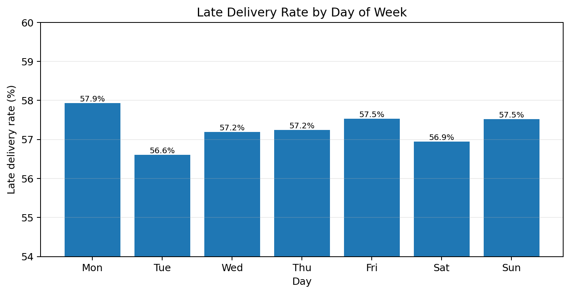
Weekday rates range from 56.60% (Tue) to 57.93% (Mon). Differences are small; avoid making major staffing or routing decisions based only on weekday averages.

4. Bottleneck and Root-Cause Signals
The notebook’s regional breakdown highlights shipping mode as a potential driver. For Central Africa, First Class was reported at 100% late (300 orders), Second Class at 82.49% (297 orders), and Standard Class at 39.8%. These values are regional findings and should not be generalized to all regions.
Other notebook findings indicate:
- Late-delivery rates are similar across customer segments, so customer segment alone may not explain the issue.
- Some department-level groups show elevated delay rates; check sample sizes and order mix before prioritizing them.
- Payment/order-status groups can show high rates, but small groups and status definitions can distort percentages.
- Regional rates are reported within a fairly narrow range in the notebook, suggesting a broader operational issue alongside local bottlenecks.

5. Predictive Model Summary
The notebook reports a Random Forest classifier with approximately 73% accuracy. Reported late-class precision is 0.78 and recall is 0.75 (F1 around 0.75), based on the displayed test results. This indicates useful but imperfect screening performance; it should support operational review, not replace it.
Validation note: the notebook appears to encode categorical variables before splitting the data. Rebuild the preprocessing pipeline so encoders are fitted only on training data, and evaluate with a leakage-safe pipeline. Confirm the exact target definition and compare against a simple baseline before deployment.

6. Recommended Actions
- High priority — audit shipping modes: Review First Class and Second Class service promises, carrier handoffs, dispatch cut-off times, and tracking gaps in the affected regions. Compare delay rate, order count, and cost together.
- High priority — define delay-related financial loss: Do not label all profit on delayed orders as “loss due to delay.” Estimate loss using a clear method, such as refunds, penalties, cancellations, incremental shipping cost, or a defensible counterfactual.
- Medium priority — investigate payment and order status: Inspect high-delay payment/status categories and verify that statuses reflect the correct point in the fulfilment lifecycle. Check the number of orders behind each percentage.
- Medium priority — monitor a weekly KPI dashboard: Track late-delivery rate, on-time rate, average delay days, order count, profit per order, and delay rate by shipping mode and region.
- Medium priority — strengthen model validation: Use a train-only preprocessing pipeline, cross-validation, class-wise precision/recall, and a time-based holdout if dates permit. Review false negatives because missed late-risk orders can be operationally costly.

7. Data and Interpretation Notes
- The notebook contains inconsistent late-order counts in different outputs (for example, 98,743 versus 98,977). Reconcile the definition and calculation before publishing final KPIs.
- The profitability categories are based on the notebook’s labels; verify whether “Loss” means strictly negative profit or profit less than or equal to zero.
- Profit associated with delayed orders is not automatically the amount of profit lost because of delays.
- All findings in this report are based on the supplied notebook outputs. Where calculations or definitions are uncertain, the report flags that limitation rather than treating it as established fact.

Conclusion
The strongest signal is the persistently high late-delivery rate of about 55%. The report points to shipping-mode and fulfilment-process checks as practical starting points, while profitability and model results should be validated before being used for high-stakes financial or operational decisions.

